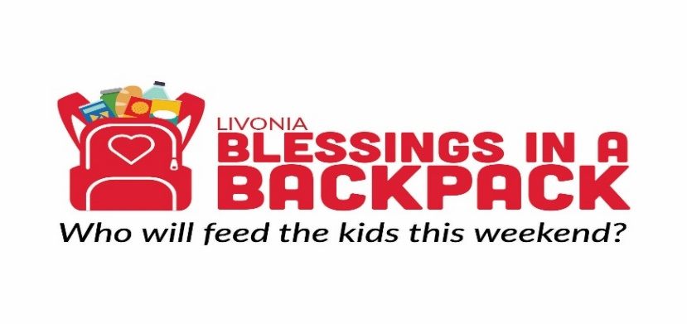
Be a Blessing- Sponsor a Child
In Livonia Public Schools, there are nearly 4,000 students eligible for free or reduced lunches. Many of these children do not receive sufficient meals or nutrition on the weekend either. The unfortunate result is that many students return to school on Mondays tired and hungry and are unable to concentrate or care about their studies.
Blessings in a Backpack – Livonia is run by a group of volunteers who form the Steering Committee. We are associated with the national office of Blessings in a Backpack (http://blessingsinabackpack.org/). We purchase the food from Meijer at a reduced cost. It costs BIAB-Livonia $100 – $110 to feed a child each weekend for a school year.
Currently, we provide eligible children at 9 Lower and Upper Elementary schools in the Livonia District with weekend food packs during the school year. At the end of the school year, we send home big boxes of cereal in our attempt to answer the need for summertime nutritional assistance. Although the students currently served is over 500 that number continues to grow.
There is still a great deal of work for us to do. Would you consider partnering with us, by sponsoring the cost of food for one child per year? Your $100 donation would ensure that we can continue filling one child’s backpack each week during the school year, so that they have adequate meals on the weekend. We would not be able to fulfill our mission without the assistance of community members like you. If you are not able to commit to $100, please know that we gratefully accept any and all donations.
- Donations can be provided by mail to:
Blessings in a Backpack Livonia
P.O. Box 51603
Livonia, MI 48151
Checks should be made payable to: Blessings in a Backpack. In the memo, please put “Livonia Michigan”
- Online donations with a credit card can be made via the links below. In the comment section, please note “Blessings Sponsor a Child”
Facebook: https://www.facebook.com/BlessingsInABackpackLivonia/
Webpage: https://www.biablivonia.org/donate-now/
If you mail in the donation, please provide the following information:
Name: __________________________________________
Email Address____________________________________
Amount of Donation______________________________
----------------------------------------------------------------------------------------------------------------------------------------------------------------------------------------------------------------
May we contact you next year to renew your donation? Yes No
--------------------------------------------------------------------------------------------------------------------------------------------------------------------
Is this donation in memory or honor of someone? Please provide contact information, so that we may send an acknowledgement.
Name: ____________________________________________
Address: __________________________________________
City, State, Zip: _____________________________________

